

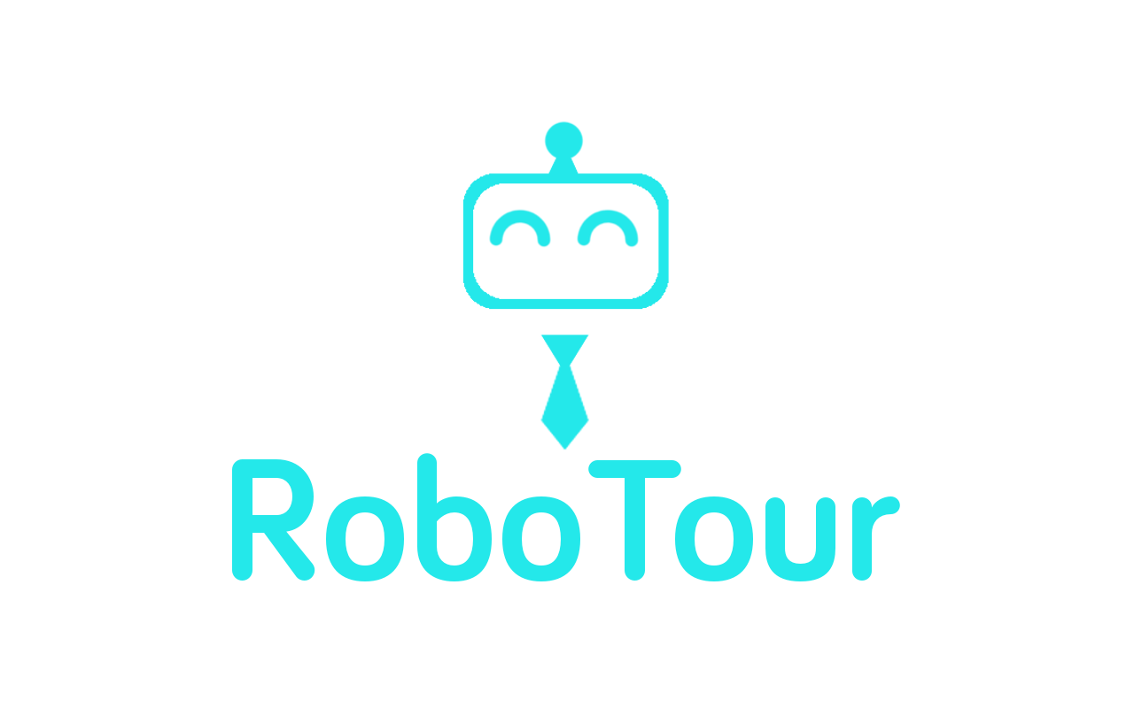

**Group 18**

Mariyana Cholakova

Michal Dauenhauer

Mahbub Iftekhar

Deividas Lavrik

David Speers

Alice Wu

Finn Zhan Chen

**1.0 Introduction** **2**

**2.0 Concept and Goals** **2**

2.1 RoboTour Specification 3

2.2 User Interface 3

2.3 Marketing: Market, User & Solution 3

2.3.1 Target User 1 - Visitors with Language Barriers 3

2.3.2 Target User 2 - Visitors who require directional assistance 4

2.4 Physical Mockup 5

**3.0 Time Planning** **6**

3.1 Technical Milestones for Client Demo 6

3.1.1 Client Demo 1 - 07/02/2018 6

3.1.2 Client Demo 2 - 28/02/2018 6

3.1.3 Client Demo 3 - 14/03/2018 6

3.1.4 Final Client Demo - 05/04/2018 7

3.2 Resource Deployment (200 hours/member) 7

3.3 Team Strengths 7

3.4 Setting up demo environment 8

3.5 Delegation and Volunteering 8

**4.0 Dependencies and Risks** **8**

4.1 Gantt Chart 8

4.2 Prototype Constraints 9

4.3 Human Risks 9

4.3.1 Differing Opinions 9

4.3.2. Not Meeting Deadlines 9

4.3.3 Illness 9

4.4 Technical Risks 10

4.4.1 Feasibility 10

4.4.2 Losing The Path 10

**5.0 Organisational Structure** **10**

5.1 Task Allocation 10

5.2 Meetings 10

5.3 Communications 11

5.4 Code/File-Sharing 11

5.5 Progress Monitoring/Tracking 11

5.6 Development Approach 11

**6 Reference** **11**

# 1.0 Introduction

Team RoboTour aims to develop a robotic tour guide system *RoboTour* that will assist people in environments such as museums or art galleries. This document describes the project plan and summary, outlining main features of the system, motivation behind it and the team’s general vision of the finished prototype. The plan focuses on processes and timelines that will be used to develop the system, identifying relevant milestones, risks and resources that are allocated to achieve the end goal.

# 2.0 Concept, goals and motivation

The interest in museums is slowly, but steadily declining. UK museums have seen a consistent decrease in the number of visitors [1]. While our civilisation has free access to abundant information, there seems not to be an efficient system to deliver it to the public.  
Museums often provide extensive resources, yet people often fail to benefit from them fully, especially if they lack necessary background. Over the years, the dwindling number of human tour guides (**could use some citation)** have been reinforced by audio-guides. Multi-language support made them more accessible to people, who are not proficient in the local language. It is worth noting that a significant number of visitors in UK is from non-english-speaking countries [**citation**].

Current systems, however, are not ideal. While comprehensive, the audio-guides (often delivered as smartphone applications) are linear and non-interactive. Moreover, they do not help navigate to the points of interest, which can be problematic in spacious venues, such as Louvre (60 600m^2) or the British Museum (75000m^2) [**wiki**]. & talk about yearly traffic  
RoboTour is designed to help solve this issues and further enhance the visitors’ experience. We hope to provide the users with an immersive and natural experience, akin to being guided by a qualified person.

## 2.1 RoboTour Specification

In order to achieve this goal, the system will have the following key features:

1. Natural and intuitive Robot-Human interaction, including speech processing and multi-language support through a companion app
2. Robust navigation and localisation mechanisms to guide people through the venue to specific points of interest over an optimised and individualised path
3. Reliable environment-sensing to ensure safe operation in a dynamic environment with people of different ages present (e.g. children and elderly)
4. Ability to deliver information on specific exhibition items, including physical identification of the piece and its elements
5. Interface allowing for customisation and planning of the tour, featuring recommendations and popular routes

Development strategy

As a proof-of-concept and a R&D platform, our team plans to develop a prototype over eleven (11) weeks. The prototype shall be a down-scaled version of the final system, yet demonstrating core functionality (subject to some limitations):

* The robot shall be able to navigate to a specified place using a system of guiding lines on the floor
* The user shall be able to interact with the robot using a smartphone application
* The robot shall avoid collisions with other objects in the test area
* The robot shall operate in a controlled, simplified environment
* The system shall provide relevant information on the mock exhibition pieces

As seen in fig **X**, the system consists of three main components. The database system is outside the scope of the prototype as its implementation will be specific to each museum. The other two components are broken up into functional blocks in the fig **X**.

Therefore the main tasks identified are:

## 

|  |  |  |
| --- | --- | --- |
| **Task** | **Resources, skills, technologies required** | **Estimated man-hours** |
| Constructing the drive-base of the robot | Electronic circuits, LEGO | 20 |
| Designing Application Graphical User Interface | Python | 12 |
| Developing App to EV3 Communication | Python, Networking | 12 |
| Constructing the motorised pointer | Kotlin, Android development | 8 |
| Designing custom line sensor | Python - Lego sensor inputs | Michal, Deividas, Mariyana |
| Basic Speech Commands | Java, Speech processing | Finn, Mahbub |
| Dynamic Collision Avoidance | LEGO sensors, python to interpret sensor data | David, Alice |
| Dynamic Navigation | LEGO sensors, python to interpret sensor data | Finn, Mahbub, David, Alice |
| Improve UI | Java, Android development | David, Alice |
| Speed Limit | Python | Michal, Deividas, Mariyana |
| Polish | All Above Technologies | Deividas, Michal, Mahbub |
| Stability | All Above Technologies | Finn, David, Alice, Mariyana |

Our team consists of 7 members, each bringing their experience in their respective areas, which will allow us to develop the project within set timeframe. The task allocation is carried out on the basis of the relative experience and time constraints on the project (i.e. each member is assigned a task of highest priority that they are most competent to carry out, unless time can be saved by less efficient, but parallel work, which effectively shortens the total development task).  
Moreover, each task will be assigned more than one person to allow discussion, collaboration and code reviews.

## 2.2 User Interface

Visitors can interact with the robot via an Android app via touchscreen and voice. The advantage of using an Android app is that most people would have a phone and existing speech recognition API from Google allows speech interaction between visitors and robots. The current version of our user Interface can be seen below in Fig 2.

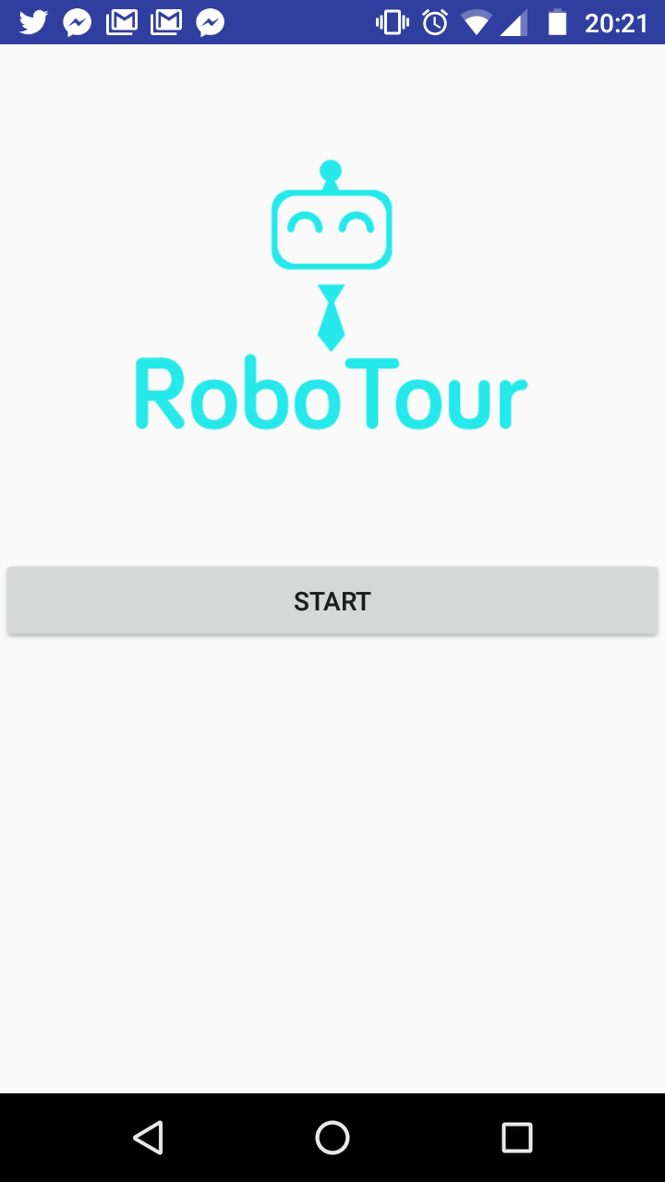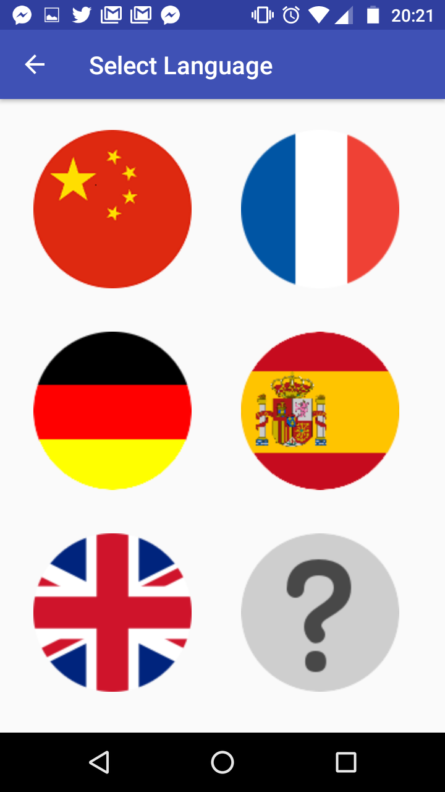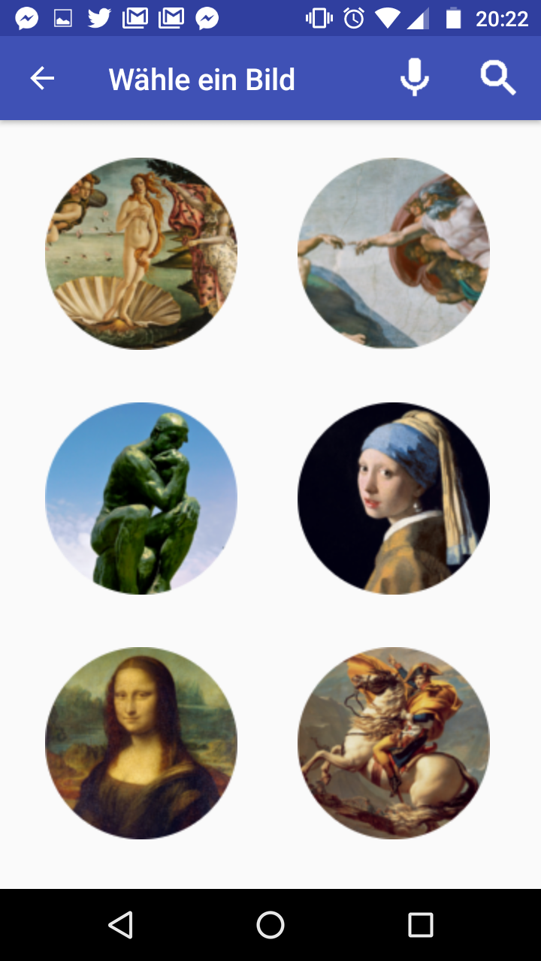

Fig 2: Our current user interface: Home Screen, Language Select, and Picture Selection respectively.

## 2.3 Marketing: Market, User & Solution

Beachhead strategy is adopted so RoboTour can concentrate on winning the market of one country before looking into other countries. UK museum is RoboTour’s beachhead market because of 2 key reasons: easier to carry out primary research, and our international team member’s personal experience with the user problems outlined next.

### 2.3.1 Target User 1 - Visitors with Language Barriers

**Problem:** UK museums have limited languages offering and are mostly dominated by English so visitors with no or limited fluency in the languages offered by museums are underserved, and thus cannot enjoy cultural immersion extensively.

**Evidence:** According to Fig 3, around 50% of annual museum visitors are from overseas. Based on primary observations, approximately 40% of them come from countries where English is not the main language and many have limited or no english fluency.

**Solution:** RoboTour’s feature 1 and 3 from section 2.1.

**Value Proposition - Revenue Increase:**

1. Better cultural immersion for overseas visitor
2. Attracts new overseas visitor with limited English fluency
3. Improved visitor experience and increased likelihood to spend

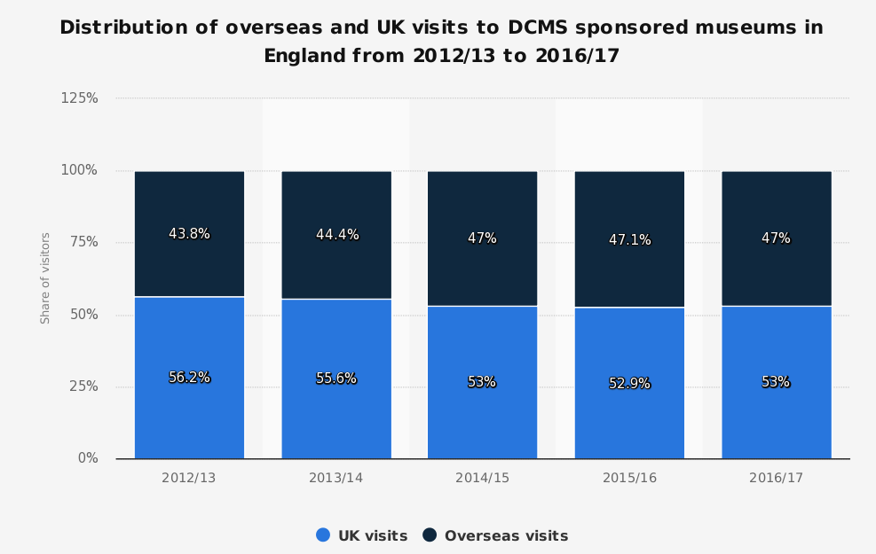Fig 3: Distribution of overseas and UK visits to Museums in England (DCMS, 2018).

### 2.3.2 Target User 2 - Visitors who require directional assistance

**Problem**: With the constant changing dynamics of art pieces in museums and limited staff training, staff members in large museums often do not know where a specific art piece is. Therefore, visitors struggle to visit all art pieces of interest effectively, thus leading to lower visitor satisfaction and missing out on some art pieces. RoboTour provides user a personalised experience so they can visit the art pieces they wish to visit, thus optimising their scarce time.

**Evidence:** Based on primary observation, the majority of visitors do not know where an art piece of their interest is located in the museum. Under these circumstances, visitors would consult leaflet maps or staff members.

**Solution:** RoboTour’s feature 2 and 4 from section 2.1.

**Value Proposition - Cost Reduction:**

1. Lower staffing cost in terms of headcount and training.
2. Lower time costs for visitors due to improved museum visitors traffic flow (optimal route planning)

## 2.4 Physical Mockup

The mockup of the prototype’s hardware setup is presented in Fig 5. The robot will feature a differential drive-base, a suite of environmental sensors and a motorised pointer to perform its designed actions.

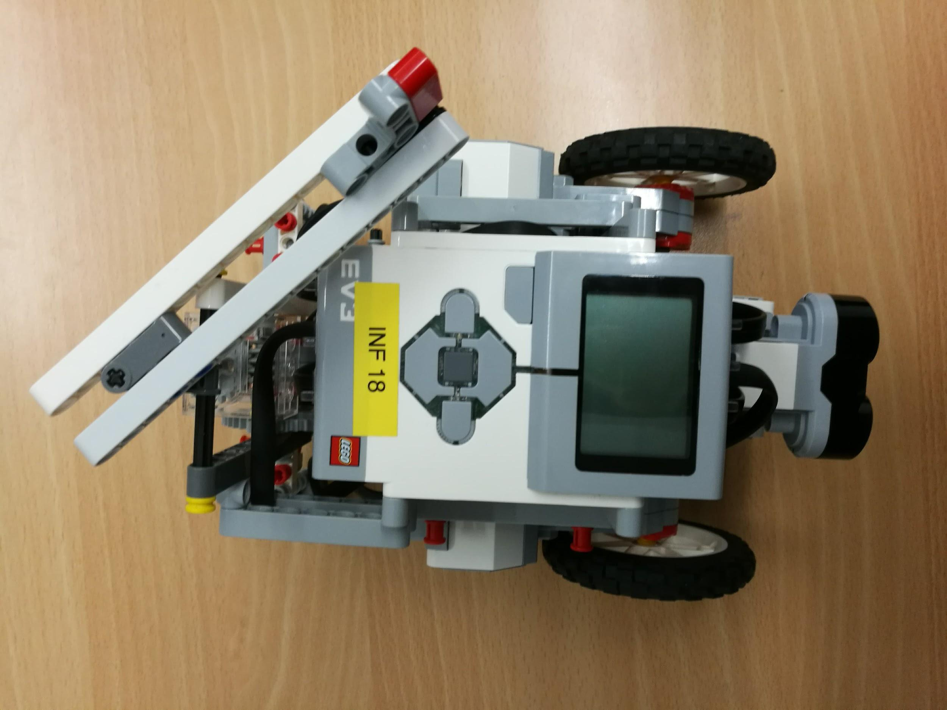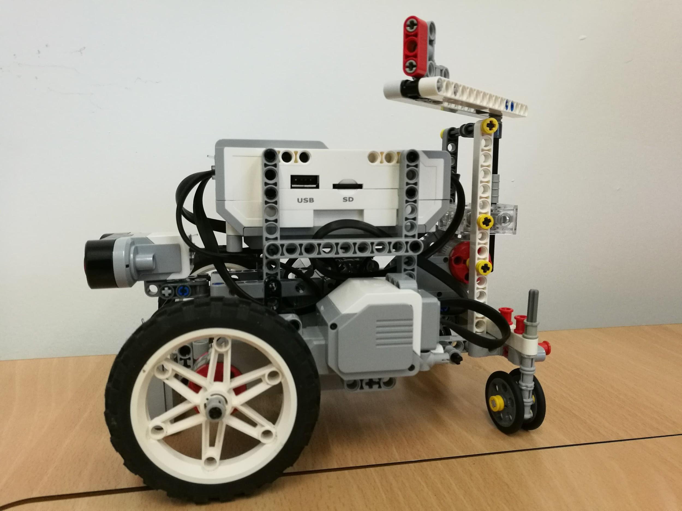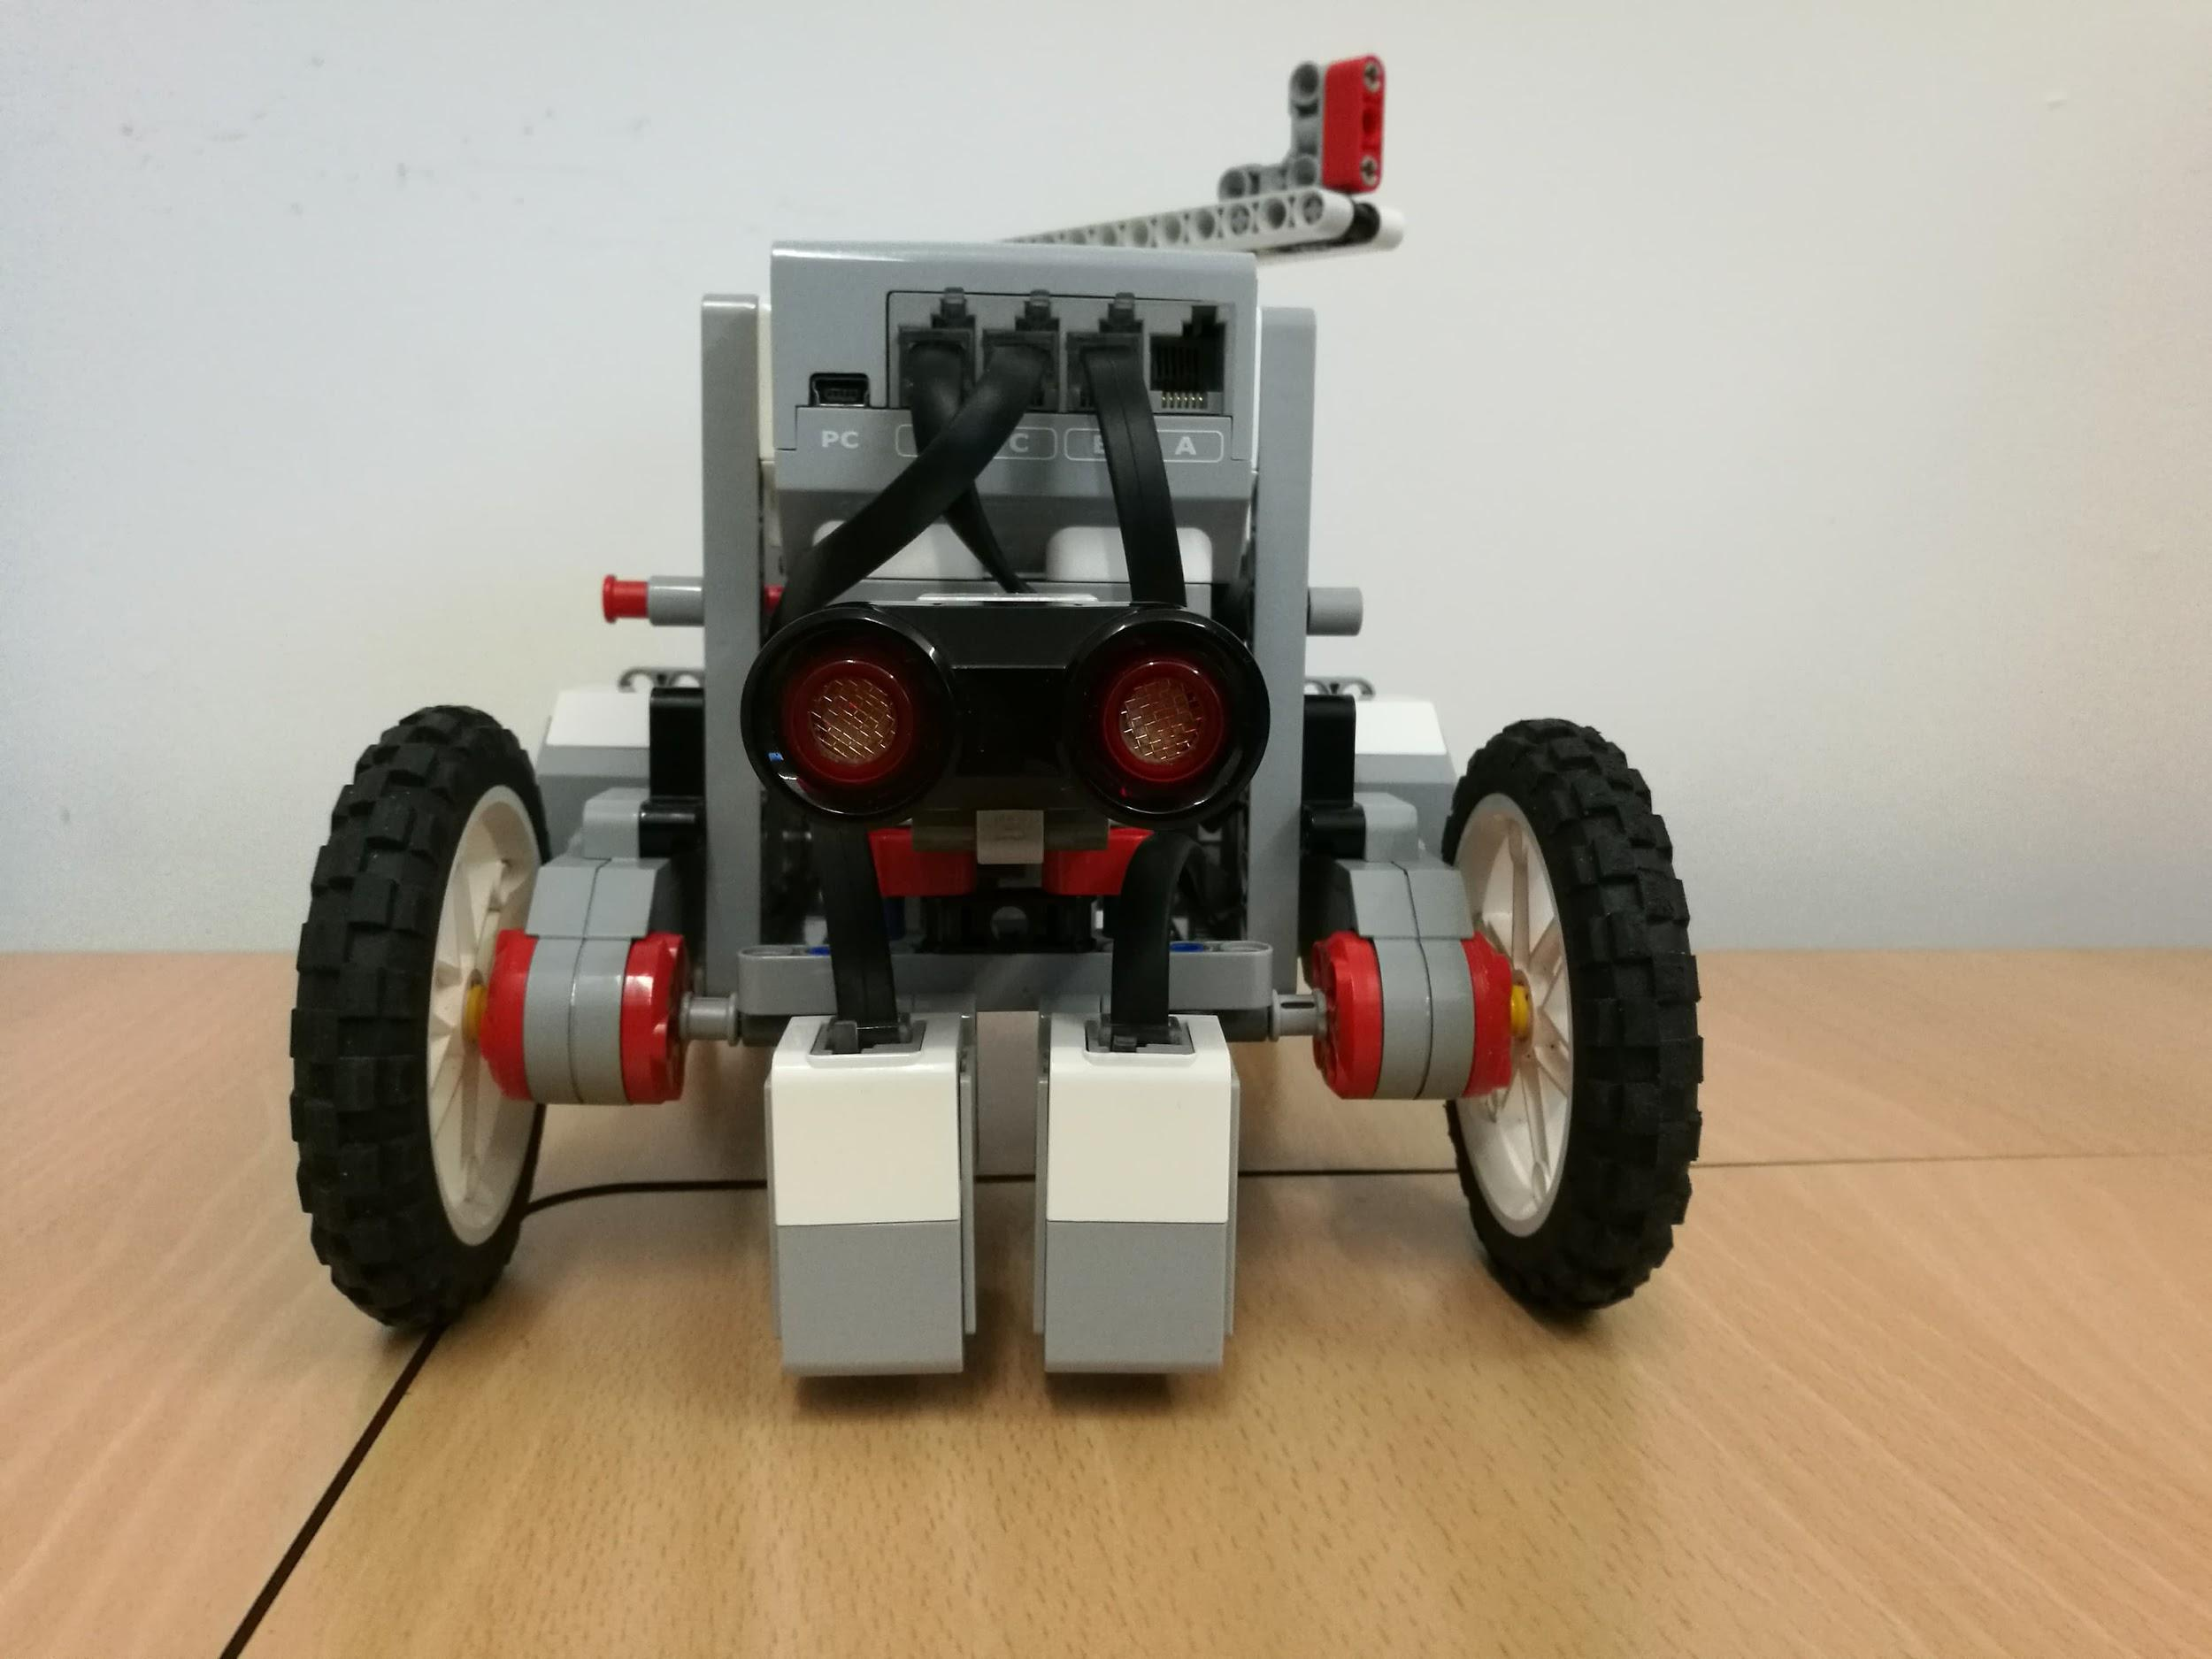

Fig 4: The current version of our robot. Top View, Side View, and Front View respectively.

# 3.0 Time Planning

## 3.1 Technical Milestones for Client Demo

### 3.1.1 Client Demo 1 - 07/02/2018

|  |  |
| --- | --- |
| **Technical Achievement** | **Evidence** |
| Basic robot built | Can show client robot with bare features: Infrared sensors, 2 color sensors, 3 motors, 4 wheels (2 motorized and 2 for stability) |
| Robot - app communication functional | The robot can follow simple commands (i.e. move forward, move backwards etc.) issued from the app |
| User Interface completed | The user is able to interact with an image-driven application using touchscreen. |
| Basic collision avoidance | The robot passively avoids collisions by stopping in front of detected objects. |

### 3.1.2 Client Demo 2 - 28/02/2018

|  |  |
| --- | --- |
| **Technical Achievement** | **Evidence** |
| Following line paths | The robot can navigate static branching line paths so that it reaches predetermined destination. |
| Basic Speech Commands | The user can interact with the robot through the app via English speech. The user can send basic commands to the robot. E.g., the user can ask the robot to “Take me to X”. |
| Dynamic collision avoidance | The robot actively avoids collisions by maintaining a safe distance from the obstacles |

### 3.1.3 Client Demo 3 - 14/03/2018

|  |  |
| --- | --- |
| **Technical Achievement** | **Evidence** |
| Speed Adjustment / Variable Speed | Allows the user to specify the speed for the tour or guidance. |
| Dynamic collision avoidance and navigation | Moving around objects blocking preferred path by moving to a secondary route by using the second line (Fig 5). Robot will be able to plan an optimal route. If both lines are blocked, the robot alerts the user and it is up to the user to clear one of the lines for the robot. |
| Improved User Interface | Allows the user to ask the robot for recommendations via text or speech. There will be a script of acceptable speech commands. |

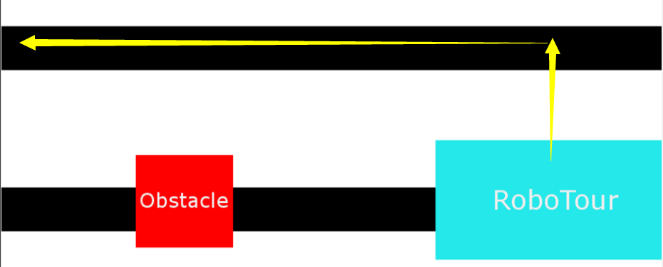

Fig 5: If RoboTour detects an obstacle it will turn and move to the other line and continue following the other line until it detects another obstacle

### 3.1.4 Final Client Demo - 05/04/2018

|  |  |
| --- | --- |
| **Technical Achievement** | **Evidence** |
| Stability | We will demonstrate to the client how the robot has achieved our set goals reliably from previous demos and per the specification. |
| Polish | We will improve on any features from previous demos that needed polish or enhancement. We will show our improved UI to the client, which will be designed to be more user-friendly compared to previous versions. |

## 3.2 Bonus Features

Some bonus features which we intend to implement if we are

## 3.3 Resource Deployment (200 hours/member)

We aim to use the 200 hours per member as efficiently as possible. Below is the detailed anticipated usage of the time per group member to achieve our goals.

This is a guide to how time will be distributed amongst different tasks for each member. Although this may change e.g. If a member is on the hardware side, they may spend more time on the robot and less time coding and vise versa. Resource are allocated using the Gantt chart in section 4.1.

|  |  |
| --- | --- |
| **Task** | **Approx time (hours)** |
| Guest lectures | 6 |
| Demonstrations | 4 |
| Group meetings (incl expected extra meetings) | 25 |
| Planning and Admin | 40 |
| Debugging & Testing | 30 |
| Code Reviews | 10 |
| Robot construction | 10 |
| Code development | 75 |

## 3.4 Team Strengths

We have allocated tasks per team members based on their strengths - this is to enable us to use our resources efficiently.

1 = Limited (red), 2 = Intermediate (yellow), 3 = Advanced(green)

|  |  |  |  |  |  |  |
| --- | --- | --- | --- | --- | --- | --- |
| **Name** | **Electronic Experience** | **OO**  **Programming** | **App**  **Development** | **Speech** | **Market Researching** | **Networks** |
| Michal | 3 | 2 | 1 | 2 | 1 | 1 |
| Mahbub | 1 | 2 | 3 | 1 | 1 | 3 |
| Alice | 1 | 3 | 3 | 2 | 1 | 3 |
| Finn | 1 | 3 | 2 | 2 | 3 | 1 |
| David | 1 | 3 | 3 | 2 | 1 | 1 |
| Mariyanna | 1 | 3 | 2 | 2 | 2 | 1 |
| Devidas | 2 | 3 | 1 | 1 | 1 | 3 |

## 3.5 Setting up demo environment

We plan to set up mock corridors using the existing layout at the back of the large lab as a demonstration area with minor modifications such as attaching mock artwork for the robot to navigate to. There will be 2 lines in our demonstration area, one of which the robot will follow at any one time. The robot will change lines when it detects an obstacle (Fig 5). Essentially the robot will have another lane - like traffic on roads - that can be used if one lane is blocked.

## 3.6 Delegation and Volunteering

We have been allocating jobs on a skills basis. It is allowed for members to volunteer to do tasks they feel comfortable doing. If volunteers are not found the group leader will allocate roles based on the strengths of the team in order to optimally allocate resources.

# 4.0 Dependencies and Risks

## 4.1 Gantt Chart

During the first 4 weeks we have multiple dependencies. Building the robot is a dependency to environment sensing as we need the robot to mount the sensors to enable us to write reliable code for sensing the environment. The robot needs to sense the environment before it can communicate with the app for movement - otherwise the robot may unintentionally bump into obstructions etc. We need to create the communication before we design the UI dependent on the background algorithms. These dependencies are shown in the gantt chart in Figure 6. 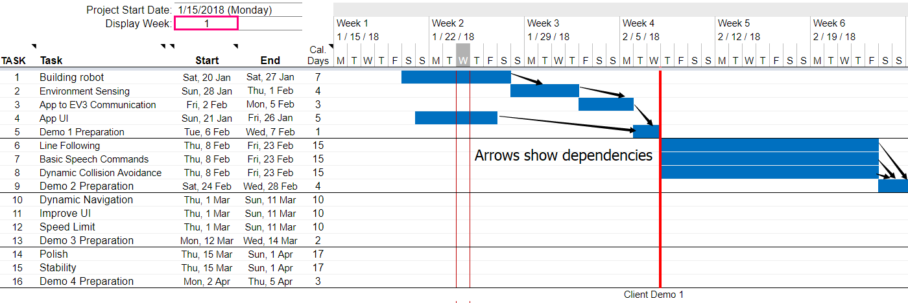

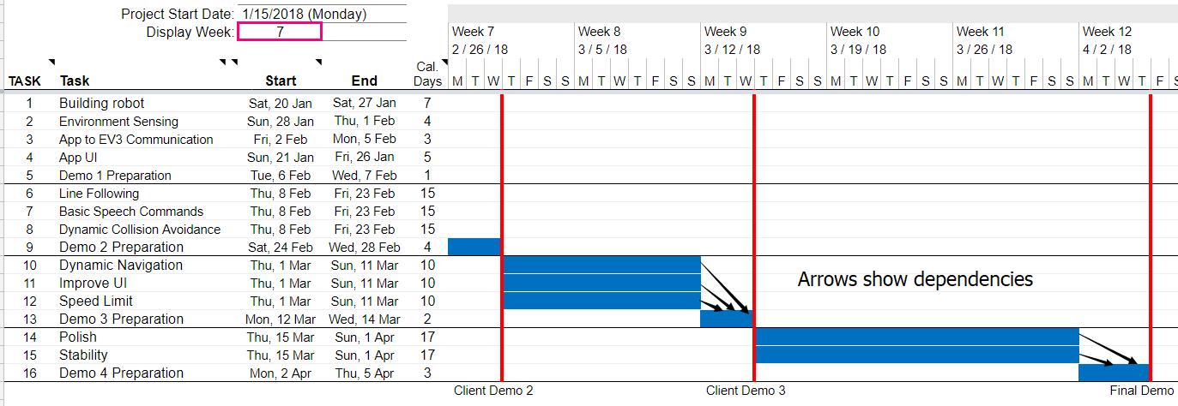

Fig 6: Project Gantt Chart with dependencies and client demos identified in red

## 4.2 Prototype Constraints

* The prototype robot can only follow lines on the ground.
* It requires that the paintings locations don’t change
* The robot will be small at this stage
* If there are obstructions on both lines the robot will not be able to continue - the robot can audiby alert the user that there is something in the way and that the user must remove it.

## 4.3 Human Risks

### 4.3.1 Differing Opinions

This will be decided by group voting. In cases when someone has a strong opinion about the direction of the project, he will be encouraged to express his concerns and the team will reconsider.

### 4.3.2. Not Meeting Deadlines

Internal deadlines are set before the final deadline to ensure we have a grace period should something unplanned occur. In cases where a team member has other priorities, he is encouraged to notify the team at least 1 week in advance so human resources are reallocated to make sure the deadlines are met.

### 4.3.3 Illness

If anyone is ill and feels that they will not be able to stick to their deadline, they are responsible for alerting the team leader in order for appropriate action to be taken by the rest of the team to help them meet the deadline. Currently Mariyana is not here, we are in contact with Mariyana, but we do not know when she will be back in Edinburgh, hence we are allocating her tasks which could be done in her absence, so the deadline could still be met. When Mariyana is back, we will explain to her what she has missed.

## 4.4 Technical Risks

### 4.4.1 Feasibility

If we discover the agreed features contain subparts which are not feasible given the technical ability and equipment available (within budget), we will try to implement the original features outlined in section 2 by replacing subparts with simpler alternative approach.

### 4.4.2 Losing The Path

RobotTour might move off track and lose its direction. RoboTour will sound a alarm and ask user to place it back to the path.

# 5.0 Organisational Structure

**Manager & Admin**: Mahbub

**Marketing**: Finn (Lead), Mariyana

**App**: David (Lead), Mahbub, Alice, Finn

**Software** **Robot**: Michal (Lead), Finn, Michal, Devidas, Alice, Mariyana, Mahbub

**Hardware** **Robot**: Devidas (Lead), Mahbub, Michal

## 5.1 Task Allocation

|  |  |  |
| --- | --- | --- |
| **Task** | **Technologies** | **Members** |
| Building Robot | Electronic circuits, LEGO | Mahbub, Deividas, Michal |
| Environment Sensing | Python | Deividas, Michal, Mariyana |
| App to EV3 Communication | Python, Networking | Mahbub, Finn |
| App UI | Kotlin, Android development | David, Alice |
| Line Following | Python - Lego sensor inputs | Michal, Deividas, Mariyana |
| Basic Speech Commands | Java, Speech processing | Finn, Mahbub |
| Dynamic Collision Avoidance | LEGO sensors, python to interpret sensor data | David, Alice |
| Dynamic Navigation | LEGO sensors, python to interpret sensor data | Finn, Mahbub, David, Alice |
| Improve UI | Java, Android development | David, Alice |
| Speed Limit | Python | Michal, Deividas, Mariyana |
| Polish | All Above Technologies | Deividas, Michal, Mahbub |
| Stability | All Above Technologies | Finn, David, Alice, Mariyana |

## 5.2 Meetings

We organized meetings at least once per week to discuss the current progress and the next target. Additionally, we have meetings with the mentor and the manager. Meeting notes where processes, key messages and targets are recorded and is properly formatted for easy retrieval in Google Drive.

## 5.3 Communications

We are using Slack for task discussion, Messenger for other discussions and using emails to contact mentor and client. Trello is the main tools for our team to manage the task. Tasks in Trello’s board are displayed as cards, and each card is assigned to groups such as “to discuss” and “To do”. In this case, each team member can find the task quickly.

## 5.4 Code/File-Sharing

GitHub is the main version control tool for our team to share code. Files are saved and shared on private Google Drive. This is to allow multiple members of the group to work on the same document at the same time, maximizing efficiency.

## 5.5 Progress Monitoring/Tracking

The manager assigns tasks and ensures meeting deadlines, and asks for progress update at weekly meetings. Each team member is encouraged to notify the team if they run into significant obstacles.

## 5.6 Development Approach

We are using Agile software development methodology. After each client demo, RoboTour will be improved according to our client’s feedback and additional features may be incorporated and so the technical features are subject to change.

# 6 Reference

VisitBritain. (2017). *Latest quarterly data for the UK overall*. [online] Available at: https://www.visitbritain.org/latest-quarterly-data-uk-overall [Accessed 25 Jan. 2018].

The Guardian (2016). *Number of Chinese tourists visiting UK soars nearly 40%*. [online] the Guardian. Available at: https://www.theguardian.com/business/2016/jan/27/chinese-tourist-numbers-coming-to-uk-up-nearly-40 [Accessed 25 Jan. 2018].

The Telegraph (2017). *Mapped: The world by English-speaking population*. [online] The Telegraph. Available at: http://www.telegraph.co.uk/travel/maps-and-graphics/mapped-english-speaking-countries/ [Accessed 25 Jan. 2018].

Department for Culture, Media and Sport (UK). (2018). *Sponsored museums annual performance indicators 2016-17*. [online] Available at: https://www.gov.uk/government/uploads/system/uploads/attachment_data/file/657464/Sponsored_Museums_Performance_Indicators_2016_17.pdf [Accessed 25 Jan. 2018].